

CAF Strategy Phase for SQL Migration

**List of Contents**

1. Strategy 3

1.1 Understanding Business Motivations 3

1.1.1 Cost 4

1.1.2 Security 4

1.1.3 Scale 5

1.1.4 Innovation 5

1.2 Business Outcomes 5

1.2.1 Fiscal Outcomes 6

1.2.2 Agility Outcomes 6

1.2.3 Reach Outcomes 6

1.2.4 Customer Engagement Outcomes 6

1.2.5 Performance Outcomes 6

1.3 Business Justification 7

1.3.1 Building business Justification 7

2. Azure Total Cost Ownership Calculator (TCO) 8

2.1 Overview 8

2.2 Define Workloads 8

2.2.1 Servers 8

2.2.2 Databases 9

2.2.3 Storage 10

2.2.4 Networking 11

2.3 Assumptions 11

2.4 Report 11

# Strategy

Documenting SQL migration strategy will assist business stakeholders and technicians in understanding the organizational benefits that entail adopting SQL migration. This section will specifically discuss following

* Business Motivations
* Outcomes
* Justifications associated with this adoption

## Understanding Business Motivations

Outlining the motivations for a business is crucial in order to construct an appropriate strategy. Business stakeholders should be included in the discussion and outlining of relevant business motivations. Business motivations for SQL cloud migration adoption are categorized into the following three general pillars.

* Critical Business Events
* Migration Motivations
* Innovation Motivations

The aforementioned categories are meant as a source of inspiration and are not an exhaustive list of all existing business motivations. However, overall motivations can be broken down further for SQL migration:

|  |  |  |  |
| --- | --- | --- | --- |
| **COST** | **SECURITY** | **SCALE** | **INNOVATION** |
| Cost reduction;  Capital Expenses;  Operation Expenses;  Datacenter exit/adopting cloud;  Bringing overall IT management, maintenance and cost down | Compliance/regulatory;  Legacy apps - Win 7 EOS;  Data sovereignty requirements; | On-demand resources onboarding;  Meeting market demands  Business agility – proactive vs. reactive  Geo expansion  Varying workforces | Building cloud native capabilities;  Extendable for future projects; Improve / Transform customer experiences of  products or services;  Disrupt the market with new products or services; |

Your motivations for cloud adoption will likely fall into multiple categories. As you're building the list of motivations, trends will likely emerge. Motivations tend to be associated more with one classification than with others. Use the predominant classification to help guide the development of your cloud adoption strategy.

When a response to critical business events is the highest priority, it's important to [get started with migration](https://docs.microsoft.com/en-us/azure/cloud-adoption-framework/get-started/migrate) early, often in parallel with strategy and planning efforts. Taking this approach requires a growth mindset and a willingness to iteratively improve processes, based on direct lessons learned.

When migration is the highest priority, strategy and planning will play a vital role early in the process. We recommend that you implement the first workload in parallel with planning efforts, to help the team understand and anticipate any learning curves that are associated with cloud adoption.

When innovation is the highest priority, strategy and planning require additional investments early in the process to ensure balance in the portfolio and wise alignment of the investment made during cloud adoption. For further information and guidance, see [Understand the innovation journey](https://docs.microsoft.com/en-us/azure/cloud-adoption-framework/get-started/innovate).

To ensure wiser decision-making, all participants in the migration process should have a clear awareness of their motivations.

The following section outlines how customers can guide and effect wiser decisions through consistent, strategic methodologies.

### Cost

One of the most consistent business motivations when adopting or migrating to a new technology is **cost**.

A well-known scenario goes as follows: how do you maintain and operate a virtualized on-prem data center in a cost-effective manner? The short answer: you cannot. There are numerous complex variables that needs to be considered when maintaining your own data center. Both operational and capital expenses are generally quite steep. Containing enough labor to continuously monitor and manage the infrastructure, coupled with the acquisition of new hardware or hardware refresh, are all elements that raise cost.

Nonetheless, migrating SQL server and adopting a cloud-based data center will make things more cost-effective. More specifically, adopting Azure SQL server significantly reduces average cost, per server, per (up to 75% in some instances), compared to the on-premise SQL server data centers. The reason being: with a multi-session layout, it is possible to have a significantly higher utilization of your resources when sharing a VM compared to build a VM and use it partly.

Azure SQL also eliminates the need for deploying your own management infrastructure since it is provided by Azure– this significantly reduces the required labor cost and additional license fees. All in all, Azure SQL brings down the overall TCO for managing and maintaining your virtualized workloads.

### Security

Security protocols and compliance issues regarding data or applications are a very common scenario in regulated industries. As such, the need to be quickly assessed but finding a solution is often complex and time consuming.

Keeping your data secure, regardless of endpoint devices, is one of Azure SQL’s many strengths. Azure has “reverse connect,” which literally negates the need for inbound traffic and reduces the overall attack surface of your ecosystem. Furthermore, Azure Active Directory authentication makes sure that all connections and user data is isolated for valid users within your ecosystem, making data sovereignty requirements easy to handle.

More recently, Windows 7 dropped support, resulting in a wide variety of compliance issues for many businesses. Azure SQL allows to upgrade automatically, cost free (Whenever a new compliance or software upgrade is enforced by Microsoft). The Infrastructure is maintained by Microsoft, so businesses do not have to be concerned with gateways or connection brokers.

If you connect Azure SQL server to your existing Microsoft ecosystem, you can take advantage of Conditional Access, Multi-Factor Authentication, Role-based Access Control present and combine it with Azure’s compliance offerings and extensive team cybersecurity experts – effectively making Azure SQL servers one of the most secure environment on the market.

### Scale

Scaling your business to accommodate new market demands, geological expansion, or remote workers is a constant scenario.

The SQL Cloud Ecosystem, with its ability to scale to any extent, can accommodate most modern-day business challenges. Azure SQL has the capacity to scale resources up or down efficiently and on demand, while also maintaining a seamless, rich end-user client experience. In addition, SQL server’s auto scale compute functionality allows companies to manage various deployment types, across a myriad of deployment planes. Also, Azure makes it possible to tailor specific virtual machines to different user groups that require dissimilar computing requirements.

Currently, Microsoft Azure boasts the largest geographical footprint of any cloud provider with more than 54 Azure Regions. This expansive footprint, in turn, enables an easy transition with new mergers and acquisitions, as well as enabling your remote workforce, irrespective of geographical location.

If a business’s data journey requires the reuse of existing investments, such as No-SQL databases, SAP Azure SQL has the inherent ability to support both persistent and non-persistent environments.

### Innovation

Innovative business motivators within our bracket generally focus on business agility and adapting to changing landscapes. In order to disrupt an existing market or satisfy an increase in demand, businesses need a sustainable and trustable environment.

The following list includes motivations that cause an IT organization to focus more on an innovate strategy than a migrate strategy.

* Increasing business agility.
* Preparing for new technical capabilities.
* Building new technical capabilities.
* Scaling to meet market demands.
* Scaling to meet geographic demands.
* Improving customer experiences and engagements.
* Transforming products or services.

As mentioned earlier, Azure SQL offers a business unparalleled agility with its unlimited scaling potential that can accommodate nearly any workload significantly faster than acquiring the equivalent hardware. Furthermore, Azure SQL offers geographically diversified team access, while, at the same time, keeping cost considerably lower.

Leveraging Azure SQL also enables any business and customers the capacity to utilize Azure’s end-to-end monitoring and diagnostic services. These services make the identification of root causes efficient and fast compared

## Business Outcomes

The most successful transformation journeys start with a business outcome in mind. Cloud adoption can be a costly and time-consuming effort. Fostering the right level of support from IT and other areas of the business is crucial to success.

During any cloud transformation, the ability to speak in terms of business outcomes supports transparency and cross-functional partnerships. The business outcome framework starts with a simple template to help technically minded individuals document and gain consensus. This template can be used with several business stakeholders to collect a variety of business outcomes, which could each be influenced by a company's transformation journey. Feel free to use this template electronically or, better still, draw it on a whiteboard to engage business leaders and stakeholders in outcome-focused discussions. To learn more about business outcomes and the business outcome template, see

* [Documenting business outcomes](https://docs.microsoft.com/en-us/azure/cloud-adoption-framework/strategy/business-outcomes/business-outcome-template), or
* Download the [business outcome template](https://archcenter.blob.core.windows.net/cdn/business-outcome-template.xlsx).

During any cloud transformation, the ability to speak in terms of business outcomes supports transparency and cross-functional partnerships. The business outcome framework starts with a simple template to help technically minded individuals document and gain consensus. This template can be used with several business stakeholders to collect a variety of business outcomes, which could each be influenced by a company's transformation journey. Feel free to use this template electronically or, better still, draw it on a whiteboard to engage business leaders and stakeholders in outcome-focused discussions. To learn more about business outcomes and the business outcome template, see

* [Documenting business outcomes](https://docs.microsoft.com/en-us/azure/cloud-adoption-framework/strategy/business-outcomes/business-outcome-template), or
* Download the [business outcome template](https://archcenter.blob.core.windows.net/cdn/business-outcome-template.xlsx).

Speaking in business outcomes can feel like a foreign language to many technically minded individuals. To help ease translation, we curate a set of business outcome examples. You can use the following examples to inspire and demonstrate business outcomes that are based on actual transformation journeys. To help you find business outcomes more easily, we've separated them into the following categories. This approach tends to drive consensus-building conversations across business units.

### Fiscal Outcomes

Financial or fiscal performance is the cleanest business outcome for many business leaders, but not the only one. View samples of [fiscal outcomes](https://docs.microsoft.com/en-us/azure/cloud-adoption-framework/strategy/business-outcomes/fiscal-outcomes).

### Agility Outcomes

Today's fast-changing business environment places a premium on time. The ability to respond to and drive market change quickly is the fundamental measure of business agility. View samples of [agility outcomes](https://docs.microsoft.com/en-us/azure/cloud-adoption-framework/strategy/business-outcomes/agility-outcomes).

### Reach Outcomes

In a constantly shrinking market, global reach (ability to support global customers and users) can be measured by compliance in geographies that are relevant to the business. View outcomes related to [global reach](https://docs.microsoft.com/en-us/azure/cloud-adoption-framework/strategy/business-outcomes/reach-outcomes).

### Customer Engagement Outcomes

Social marketplaces are redefining winners and losers at an unheard-of pace. Responding to user needs is a key measure of customer engagement. Learn more about [customer engagement outcomes](https://docs.microsoft.com/en-us/azure/cloud-adoption-framework/strategy/business-outcomes/engagement-outcomes).

### Performance Outcomes

Performance and reliability are assumed. When either falters, reputation damage can be painful or long-lasting. Learn more about [performance outcomes](https://docs.microsoft.com/en-us/azure/cloud-adoption-framework/strategy/business-outcomes/performance-outcomes). Each of the business outcomes listed in the preceding categories can help facilitate a focused conversation among your business and technical team members. However, you shouldn't limit your conversations to these generic samples. Understanding the unique needs of your own business, and building outcomes that match, maximizes the value of a cloud transformation.

## Business Justification

Cloud migrations can generate early return on investment (ROI) from cloud transformation efforts. But developing a clear business justification with tangible, relevant costs and returns can be a complex process. This section will specifically discuss the following:

### Building business Justification

The following process defines an approach to developing the business justification for cloud migrations. For more information about the calculations and financial terms, see the article on [financial models](https://docs.microsoft.com/en-us/azure/cloud-adoption-framework/strategy/financial-models).

At the highest level, the formula for business justification is simple. But the subtle data points required to populate the formula can be difficult to align. On a basic level, the business justification focuses on the return on investment (ROI) associated with the proposed technical change. The generic formula for ROI is:

|  |
| --- |
| $$Return on investment\left(ROI\right)= \frac{Gain from investment-Intial investment}{Initial Investment}$$ |

Some additional resources to help you take important considerations into account when working on business justification:

* Cloud providers offer calculators to estimate cloud investments. Microsoft provides the [Azure pricing calculator](https://azure.microsoft.com/pricing/calculator).
* Some cloud providers also offer cost-delta calculators. Microsoft provides the [Azure total cost of ownership (TCO) calculator](https://azure.microsoft.com/pricing/tco/calculator).
* For more refined cost structures, consider a [digital estate planning](https://docs.microsoft.com/en-us/azure/cloud-adoption-framework/digital-estate/) exercise.
* Estimate the cost of migration.
* Estimate the cost of any expected training opportunities. [Microsoft Learn](https://docs.microsoft.com/en-us/learn) might be able to help mitigate those costs.
* At some companies, the time invested by existing staff members might need to be included in the initial costs. Consult the finance office for guidance.
* Discuss any additional costs or burden costs with the finance office for validation.

For more see - <https://docs.microsoft.com/en-us/azure/cloud-adoption-framework/strategy/financial-models>

# Azure Total Cost Ownership Calculator (TCO)



## Overview

[Azure Total Cost of Ownership (TCO)](https://azure.microsoft.com/en-us/pricing/tco/calculator/) is the cost of a product or service plus any operating costs. You can use TCO to weigh risk against reward when acquiring services, hardware, or applications. TCO calculations are key to strategic procurement and ensuring the greatest possible return on investment (ROI). To calculate TCO, you need to use a variety of tools and processes which can help you assign dollar amounts to intangibles. When calculating TCO for on-premise purchases, you should consider facility and labor costs. For public clouds, it can be easier to estimate TCO because all aspects of the computing services are provided and priced by the cloud provider.

**Pros:**

* Granularity of inputs
* You can modify the values the report uses (i.e. IT Labor Costs), but only within the Assumptions (not within the export)
* Good summarization and visuals to present to Management level

**Cons:**

* You need to input multiple fields and multiple lines to assess a complete environment (therefore accurate input is time-consuming)
* The Excel export does not re-adjust the calculations if you edit the values
* Unable to save current session/state to complete at a later point in time

Azure TCO has three stages Assessment, Assumptions and viewing Report. All three stages are discussed below in detail

## Define Workloads

In this stage providing detail information of on-premises will help us get precise estimation from TCO. Details includes networking, servers, storage, and databases. This information can take time to gather if you don’t already have it available. If you have multiple set-ups or possible configurations, you need to run the TCO Calculator multiple times. Unfortunately, this tool cannot save a session so make sure to save the report before moving on to the next configuration.

### Servers

The first information to fill out in assessment is about on-premises server infrastructure. Explanation of every field in server section is as follows:

* **Workload:** On-premises workload type Web App or Windows/Linux Server
* **Environment:** Specifying if the workload runs or physical server or Virtualized Server
* **Operating System:** OS installed on the servers Windows or Linux
* **Servers:** Number of servers for that workload
* **Procs per server:** Number of Processor per server
* **Core per Procs:** Number of Core per Processor
* **RAM:** Amount of RAM in GB per server
* **Optimize by:** Specifies whether compute or memory is more important to the workload. If an Azure Virtual Machine does not exactly fit your specifications, the Calculator will seek to match cores or memory based on your specification.
* **Auto Scaling:** Only check the box if the workload is required to be scaled on demand.

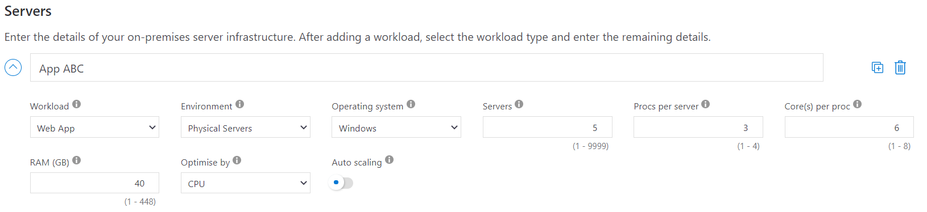

**Example:** In the above image we have named our workload as “App ABC”. The workload type is a Web Application which runs on physical server. We have installed Windows OS on those servers, so we have selected Windows in the above image. Next step is to specify the number of servers required for that application which in our case was 5. We currently have 3 processors per server each with 6 cores. Required RAM for this application is 40 GB and selecting CPU as optimization method. Once we have filled all our information TCO will estimate the expenses for the equivalent environment in Azure.

### Databases

In this section all the information regarding on-premises databases as well as Azure SQL Database to which you want to migrate is required. User needs to add the following details for each database. Explanation of every field in source database (single) section is as follows:

* **Database:** Database engine (MS SQL Server/MySQL/PostgreSQL) used in on-premises environment.
* **License:** If using MS SQL Server Database engine then License information (Enterprise/Standard) is needed.
* **Environment:** Specifying if the workload runs or physical server or Virtualized Server
* **Operating System:** OS installed on the servers Windows or Linux
* **Servers:** Number of servers for that workload
* **Procs per server:** Number of Processor per server
* **Core per Procs:** Number of Core per Processor
* **RAM**: Amount of RAM in GB per server
* **Optimize by:** Specifies whether compute or memory is more important to the workload. If an Azure Virtual Machine does not exactly fit your specifications, the Calculator will seek to match cores or memory based on your specification.
* **SQL Server 2008/2008 R2:** Specifies if the on-premises database environment is SQL Server 2008/2008 R2. This will model the financial effects of the end of extended support which begins July 2019.

Fields of Destination Databases or Azure Databases:

* **Service:** Azure database service(s) available given your on-premises environment.
* **Max DB Size (GB):** Maximum size of on-premises Database.
* **Max Concurrent Logins:** Maximum number of concurrent logins to the on-premises database

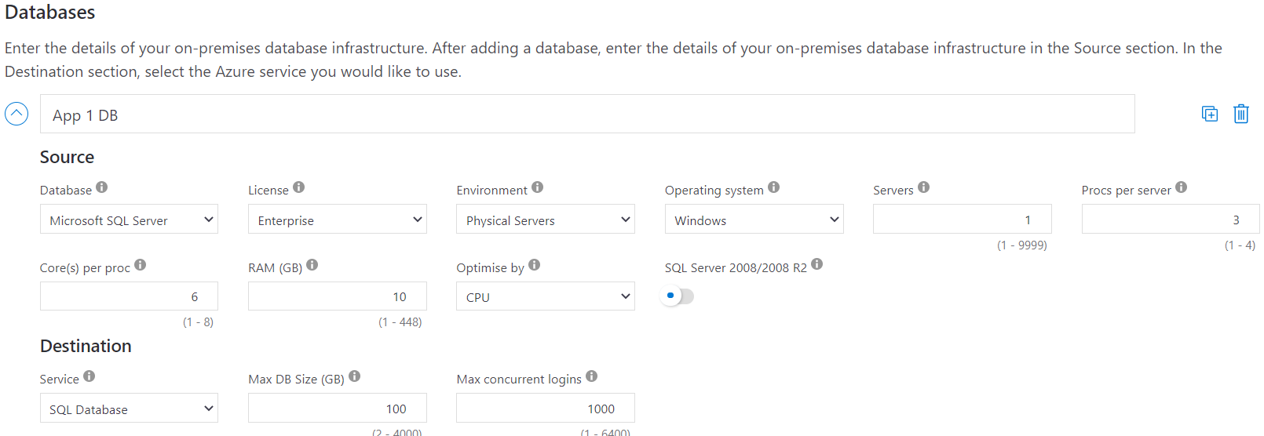

**Example:** In the above image we have named our source Database as “App 1 DB”. The Database engine is a Microsoft SQL Server enterprise edition running on physical server with windows OS. We have specified the number of servers required for this workload which in our case was 1. We currently have 3 processors per server each with 6 cores. Required RAM for this application is 10 GB and selecting CPU as optimization method. In the Destination Database we are planning to migrate to Azure SQL Database. Next we have specified 100 GB as maximum on-premises Database Size and 1000 as Maximum concurrent logins. Once we have filled all our information TCO will estimate the expenses for the equivalent environment in Azure SQL Database

### Storage

Final Important Section before Networking is Storage where we need to specify all the details of on-premises storage infrastructure.

* **Storage Type:** Type of Storage being used on-prem. If you select local disk, then you have to mention the disk type (SSD/HDD)
* **Accessibility:** Percentage of data being access frequently
* **Capacity:** Amount of primary storage used on-premises
* **Backup:** Amount of backup storage used on-premises
* **Archive:** Amount of archive storage used on-premises

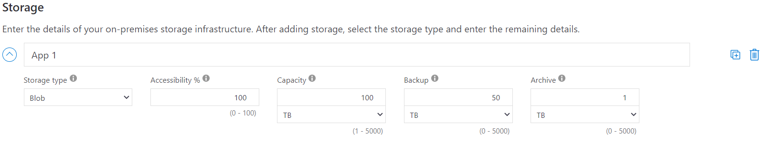

**Example:** In the above image we have named on-premises storage as “App 1”. The type of storage use on-premises is Blob storage with 100% accessibility, 100TB capacity and 50 TB Backup Capacity. For this example, we don’t have archive storage on-premises. Once we have filled all our information TCO will estimate the expenses for the equivalent environment in Azure.

### Networking

This section only requires the information about monthly consumption of network bandwidth.

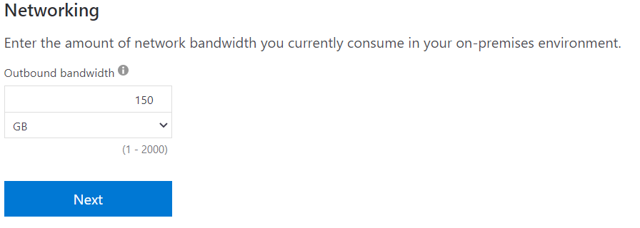

**Example:** Continuing our example we will specify 150 GB monthly network bandwidth for on-premises workload.

## Assumptions

After providing all the on-premises detail the next important step is review the assumption page. This page lists known options for the components and configurations you provided broken down by headings. Under each heading full details of your current system are included. Azure has predefined costs for the on-premises resources which needs to be review and make changes to any that are incorrect. IT budgeting Spreadsheets can be useful in this scenario. The following are the important topics to review and update as per your company standards.

* Software Assurance coverage (provides Azure Hybrid Benefit)
* Geo-redundant storage (GRS)
* Virtual Machine costs
* Electricity costs
* Storage costs
* IT labor Costs

Microsoft follows industry averages accredited by Nucleus Research. It’s recommended tocontinue with those assumptions as such.

## Report

After confirming that your details are correct, you can run the calculations. You can then review your estimated costs for Azure resources and services.

**Example**: In the below generated report we are looking at 3-year timeframe which TCO will forecast the savings for next 3 years in region “West US”. You can select any region across the world depends on business needs.

